- Be sure to fill the form of forgot your password.

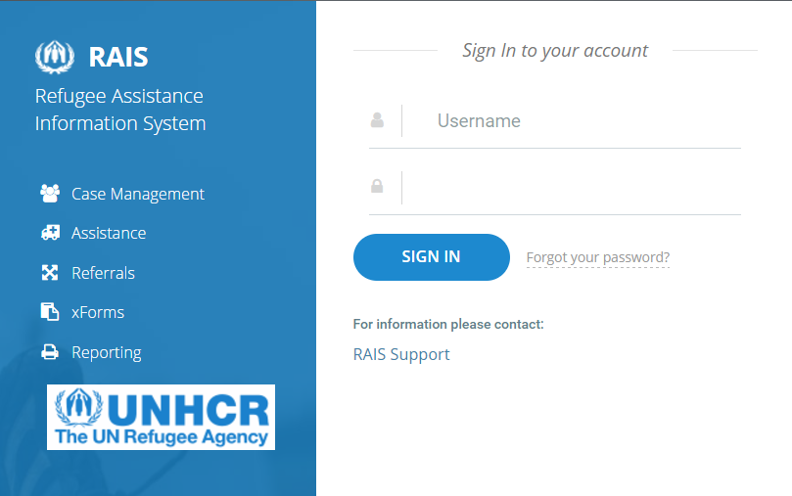

- Fill the form properly. And click SEND PASSWORD RESET LINK.

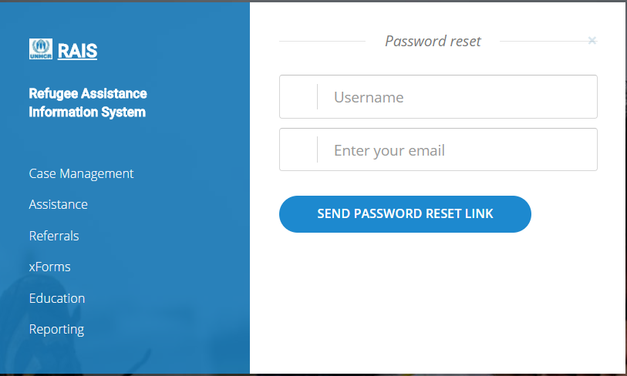
- Within a few minutes; if you do not receive an email means outlook has took the email in quarantine. In this case go to your outlook inbox and search for quarantine@unicc.org . You must have an email from previous days. Open the mail and click Manage My Account new page will be open.

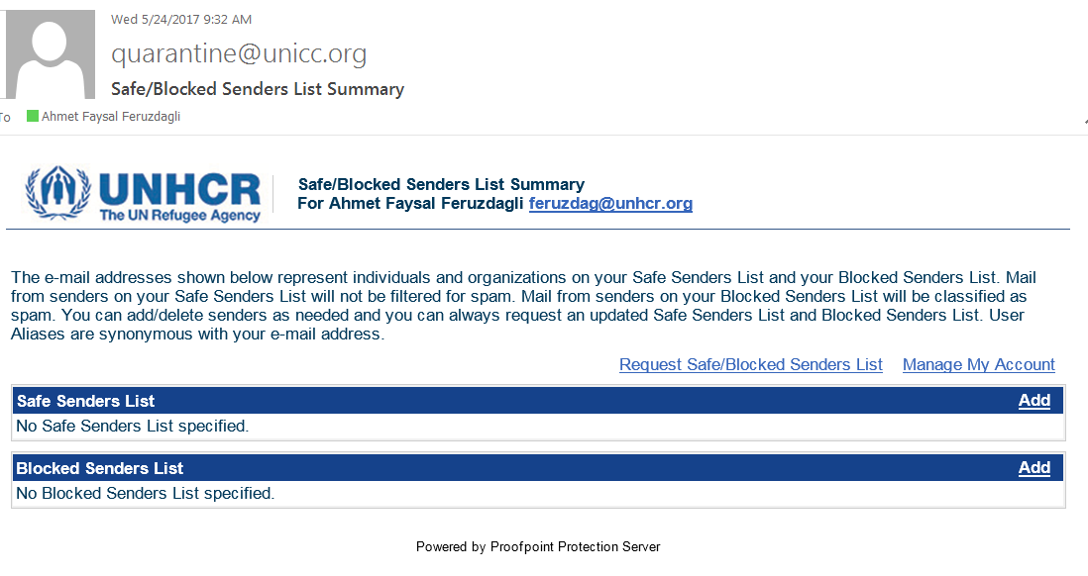

- Select turanrai@unhcr.org from the list and firstly click Allow Sender and then click Release . Go back to your outlook inbox, you will have that email in your inbox.

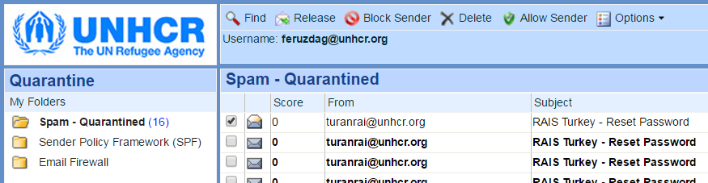

- Keep in mind that the received password need to be filled manually, copy past is not accepted.

